NAME – ANIRUDDHA PRATAP SINGHPRN :25070122247 Batch – C2 COURSE – JAVA

Experiment 11-
Write a Java program to demonstrate the implementation of interfaces AIM – Write a Java program to demonstrate the implementation of interfaces
Program 11
interface Vehicle {
void start();
void stop();
}
// Car class implementing Vehicle interface class Car implements Vehicle {
public void start() {
System.out.println(&quot;Car is starting.&quot;); }
public void stop() {
System.out.println(&quot;Car has stopped.&quot;); }
}
// Bike class implementing Vehicle interface class Bike implements Vehicle {
public void start() {
System.out.println(&quot;Bike is starting.&quot;); }
public void stop() {
System.out.println(&quot;Bike has stopped.&quot;); }
}
// Main class
public class VehicleInterface {
public static void main(String[] args) {
// Interface reference for Car
Vehicle car = new Car();
car.start();
car.stop();
System.out.println();
// Interface reference for Bike
Vehicle bike = new Bike();
bike.start();
bike.stop();
}
}
Output
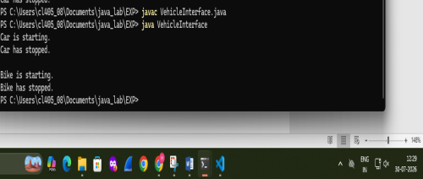
EXERCISE
11.1 . Create an interface Printable and implement it in Student and Employee classes.
Program 11.1 -
// Interface
interface Printable {
// Abstract method
void printDetails();
}
// Student class
class Student implements Printable {
// Implementing interface method
public void printDetails() {
System.out.println("Student Name : Sourabh Gupta");
System.out.println("Roll Number : 101");
}
}
// Employee class
class Employee implements Printable {
// Implementing interface method
public void printDetails() {
System.out.println("Employee Name : Sourabh Gupta");
System.out.println("Employee ID : 501");
}
}
// Main class
public class Main {
public static void main(String[] args) {
// Creating objects
Student s = new Student();
Employee e = new Employee();
// Calling methods
System.out.println("Student Details:");
s.printDetails();
System.out.println();
System.out.println("Employee Details:");
e.printDetails();
}
}
Screenshot 11.1 –
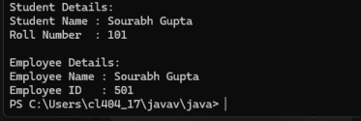
Program 11.2 - Create an interface Switchable with a method turnOn(). Implement the interface in Light and Fan classes to display the device status.
interface Switchable {
void turnOn();
}
// Light class implementing Switchable interface class Light implements Switchable {
public void turnOn() {
System.out.println("Light is turned ON."); }
}
// Fan class implementing Switchable interface class Fan implements Switchable {
public void turnOn() {
System.out.println("Fan is turned ON."); }
}
// Main class
public class SwitchableDemo {
public static void main(String[] args) {
// Interface reference for Light
Switchable light = new Light();
light.turnOn();
System.out.println();
// Interface reference for Fan
Switchable fan = new Fan();
fan.turnOn();
}
}
Screenshot 11.2 –
